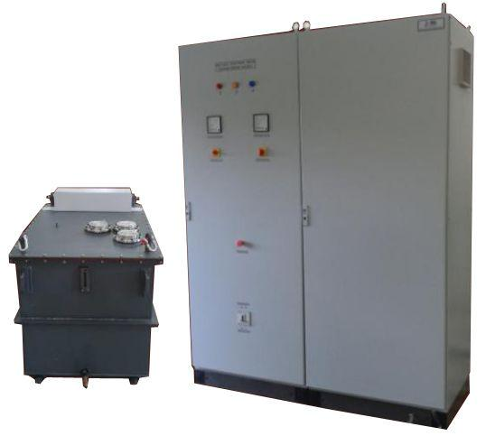
IONICS has designed, developed and supplied regulated power supplies for
POWER SOURCE FOR ELECTRON BEAM WELDING
Upto 20kW
Electron Beam Welding equipment using the high frequency
resonant / PWM-Controlled switch mode topology.
The entire power source consists of the following:
- Acceleration Voltage Supply
- Filament Heating Supply floating on high voltage
- Bias Supply floating on high voltage
- Focusing Supply
- Beam Oscillation supplies (X and Y) 2 sets
- Beam Deflection supplies (X and Y) 2 sets
The unit is divided into two parts:
- The HT Tank
- The Control Cubicle
The HT tank houses the high voltage section of the Acceleration supply and also the Filament Heating Supply and the Bias Supply, each floating at -100kV.
The control cubicle houses the Beam Oscillation and the Beam Deflection Supplies, electronic controllers for the Acceleration supply, Filament Supply and Bias supply
- OEM Customization available

Technical Specifications
PARAMETER | SPECIFICATION
Input Voltage | 415V ±10% A C, 50Hz, three phase
Duty | Continuous operation
Protections | HRC fuses at mains input  Single phasing preventer  Line filter at mains input  Thermal overload relays  Various interlocks
Controls & Signals on Control Panel for all the power supplies | Key switch to enable/disable the whole system  Emergency OFF push button  Selector switch for local/remote selection  ON/ OFF push buttons  10 turn potentiometers for voltage & current control  LED indications for ON/ OFF status  LED indications for fault status
ACCELERATIO N VO LTAGE SUPPLY
Output Voltage Range* | Upto -100kV DC
Output Current Range* | Upto 200mA
Output Voltage Control | 0 to rated voltage
Output Current Control | 0 to rated current
Line Regulation | ≤ 0.1% for 10% variation in input voltage
Load Regulation | ≤ 1% for 0 to 100% load variation
Stability | < 0.1%
Ripple | ≤ 1% rms of rated voltage
Resolution | 100V for voltage and 0.1mA for current
Repeatability in Settings | < 1%
Protections | Against over current, over voltage, over temperature, short-circuit
FILAMENT HEATING SUPPLY
Output Voltage Range | Upto 10V DC
Output Current Range | Upto70A
Output Voltage Control | 0 to rated voltage
Output Current Control | 0 to rated current
Insulation Level | Floating on -100kV DC
Protections | Against over current, filament open
BIAS (GRID ELECTRO DE) SUPPLY
Output Voltage Range | Upto -3500V DC
Output Current Range | Upto 10mA
Output Voltage Control | 0 to rated voltage
Insulation Level | Floating on -100kV DC
Regulation | ±1%
Ripple in Voltage | ≤ 1% peak to peak
Stability | < 1%
Protections | Against short circuit
Control Loop | Control loop senses the beam current and required ramp -up timing
FOCUSING SUPPLY
Output Voltage | Upto 150V DC
Output Current | Upto 15A
Output Voltage Control | 0 to rated voltage
Output Current Control | 0 to rated current
Ripple | ≤ 0.1% rms
Mode of Regulation | Constant current-constant voltage
Protections | Against over current, short circuit
BEAM OSCILLATIO N SUPPLIES (X & Y) 2 SETS
Output Voltage | Upto 10V A C sinusoidal
Output Current | Upto 2A
Voltage Control | 0 to rated voltage
Frequency | Variable from 50Hz to 1kHz
Phase Shift | Adjustable phase shift of 0 to 180˚ between the two sets of outputs
Line Regulation | ≤ 0.1% for 10% variation in input voltage
Load Regulation | ±1%
Protections | Against over current
BEAM DEFLECTIO N SUPPLIES (X & Y) 2 SETS
Output Voltage | Upto 30V DC
Output Current | Upto 5A
Output Voltage Control | 0 to rated voltage
Output Current Control | 0 to rated current
Polarity | Positive / negative (selectable through switch)
Line regulation | ≤ 0.1% for 10% variation in input voltage
Load regulation | ≤ 0.1%
Ripple | ≤ 0.1% rms
Mode of Regulation | Constant current-constant voltage
Protections | Against over current, short circuit
*Optional. To be specified by the user.

For any queries or customization requests contact us at info@ionics.co.in
For product line information visit us at www.ionics.co.in

